
East West University
Department of Computer Science and Engineering

Course: CSE251 Electronic Circuits
Expt No.: 2
Title: Half-Wave Diode Rectifier Circuit

Objectives:
- To study half-wave diode rectifier circuit.
- To study the effect of a capacitor filter on the output of the rectifier circuit.

Introduction:
A rectifier circuit converts an AC voltage with zero average into a unidirectional voltage with a non-zero average. The rectifier circuit can rectify both positive and negative half-cycles (full-wave rectifier) or only the positive half-cycle (half-wave rectifier) of a sine wave. A capacitor connected across the load resistor acts as a filter and reduces the ripple of the output voltage. The time constant of the RC network should be much larger than the period of the AC source voltage for effective filtering.

Circuit Diagram:
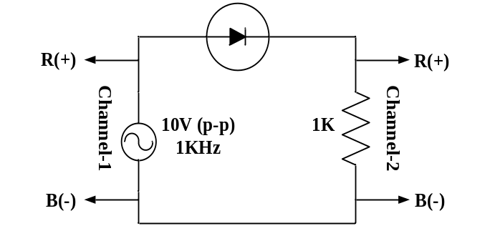
Figure 1. Set up for a half-wave diode rectifier circuit.

Equipments and Components Needed:
- Signal Generator
- Digital multimeter
- Diode (1 pc)
- Resistor 1KΩ (1 pc)
- Capacitor 10μF (1 pc)
- Breadboard
- Connecting wires

Pre-Lab Report Question:
- Consider the half-wave rectifier circuit shown in Figure 1. It is fed by a 1.0 KHz sinusoid having a peak value of 5V. Design the circuit (determine the value of the parallel capacitor) so that the output will have a peak-to-peak ripple of 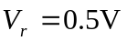 using the formula 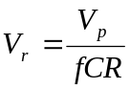. Calculate the diode conduction time  and conduction angle 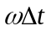 using the formula 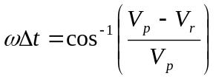. Also calculate the average and peak values of the diode currents using the formulas 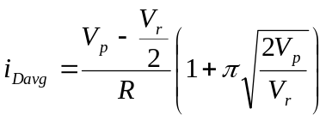 and 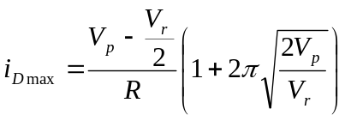.

Lab Procedure:
- Measure the resistance and write it down.
- Setup the circuit shown in Figure 1.
- Setup a 10 volts peak-to-peak, 1 KHz sine wave signal from the signal generator and observe it in channel-1 of the oscilloscope.
- Give input to the circuit and observe the output in channel-2 of the oscilloscope.
- Observe both the input (in channel-1) and the output (in channel-2) signals by setting dual mode in the oscilloscope.
- Measure the difference in peak values (ΔV_{p}) between the input and the output, and write it down.
- Connect the capacitor from your design in the pre-lab report in parallel with the resistance and observe the output only.
- Measure the time (Δt) during which the diode conducts (time between the lower peak to the upper peak of the ripple voltage, that is, the time of charging the capacitor) and write it down.
- Measure the peak-to-peak ripple voltage (V_{r}) from oscilloscope and write it down.
- Measure the average value of output voltage (V_{O}) using the DC mode of the multimeter and write it down.
- Have the datasheet signed by your instructor.

Post-Lab Report Questions:
- Compare the measured value of ΔV_{p} with the built-in voltage of Expt 1.
- Compare your measured Δt with your prelab value and make a comment.
- Calculate the peak-to-peak ripple voltage from the formula 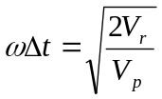 and compare it with your measured data and prelab data and make a comment.
- Calculate the average output voltage from 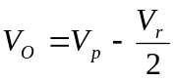 and compare it with the measurement.
- With 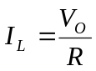, calculate the average and maximum diode currents using the formulas 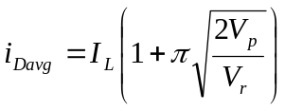 and 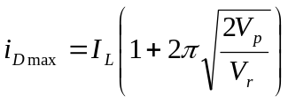 and measured value of V_{r} and compare with your pre-lab values and make a comment.
- Simulate the half-wave rectifier circuit in PSPICE for C = 10 μF and submit the input and output plots (on same graph). Use transient analysis of PSPICE for 4 cycles of input (4 ms). Modify the diode parameters following the same procedure and the same parameters values used in Expt 1.

